Catholicism 101: I Believe in God, Creator of Heaven and Earth

References:
Catechism of Catholic Church: 282-301
Genesis Chapter 1

Notes from the Catechism: 282-301

Catechesis on creation is of major importance. It concerns the very foundations of human and Christian life (CCC 282)

Origins and ends – these questions are decisive for he meaning and orientation of our life and actions.

Questions beyond the merely physical – questions of physics are prompted by “a question of another order, which goes beyond the proper domain of the natural sciences. It is not only a question of knowing when and how the universe arose physically, or when man appeared, but rather of discovering the meaning of such an origin: is the universe governed by chance, blind fate, anonymous necessity, or by a transcendent, intelligent and good Being called “God”?
(CCC 284)

Personal Notes:

What does the Bible Say about God as Creator?

Look up the following Bible references, what do they say about God as Creator?
Questions to think about:
- What is the purpose of Creation?
- Why did God Create Universe?
- Through which person of the Trinity was Universe created?
- What was Universe created out of?
 | Bible Ref. | Message
1 | Genesis 15:5
2 | John 1:1-3
3 | Jeremiah 33:19-26
4 | Isaiah 44:24
5 | 1 Corinthians 15:28
6 | Wisdom 9:9
7 | Colossians 1:15-17
8 | Genesis 1:26
9 | Wisdom 11:24-26
- What does God think about his Creation?

Genesis Chapter 1: In the Beginning, God Created the Heavens and Earth

Ancient Near Eastern World View

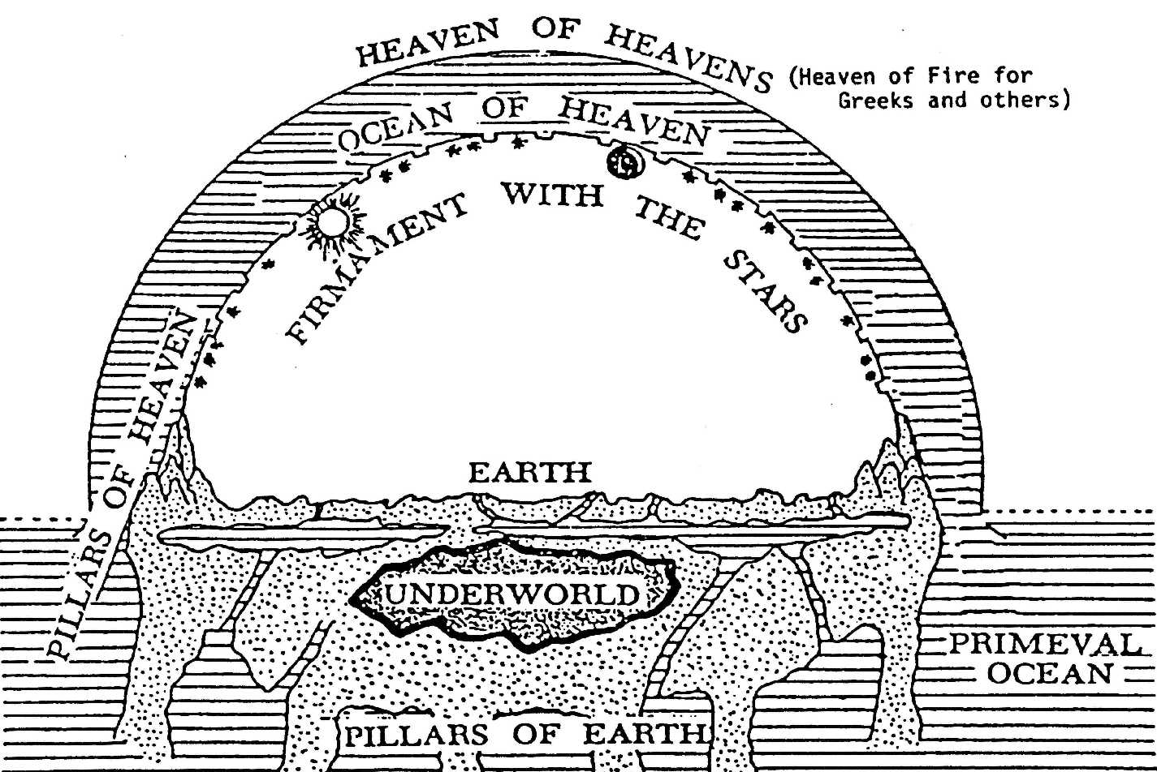

Personal Notes:

Think about the difference between the physical setting of the narrative and the religious truths the narrative is attempting to convey.

Compare the differences and similarities between the Creation account in Genesis 1 and 2 Maccabees 7:28 , with the Pagan (Babylonian and Egyptian accounts). Think about: How is Universe created? Who is involved in Creation? What is Universe made of? Who has power? How do they get power? What is purpose of humans? Did Universe have a beginning?

GENESIS | EGYPTIAN AND BABYLONIAN
 | 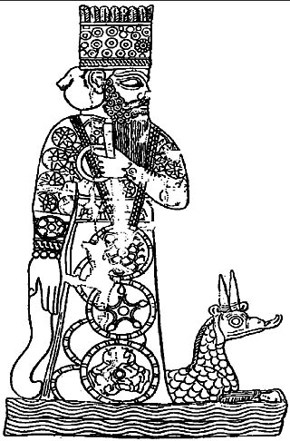

Summary of Religious Truths in Genesis & Maccabees

Personal Notes:

Church Teachings and Debates about Creation

Quotes from Pope John Paul II
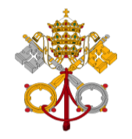
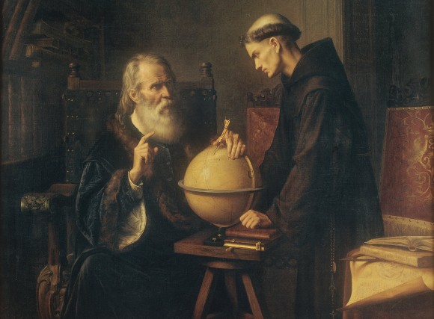
“Religion is not founded on science nor is science an extension of religion. .... Christianity possesses the source of its justification within itself and does not expect science to constitute its primary apologetic. ” [JPII 01.07.1988 Address to Vatican Observatory]

“ To desire a scientific proof of God would be equivalent to lowering God to the level of the beings of our world ... Science must recognize its limits and its inability to reach the existence of God: it can neither affirm nor deny his existence.” [JPII 10.06.1985 General Audience]

Galileo Galileo

Contrary to popular belief, Galileo was not burnt at the stake, but he was reprimanded by the Vatican and kept under house arrest for disobedience..

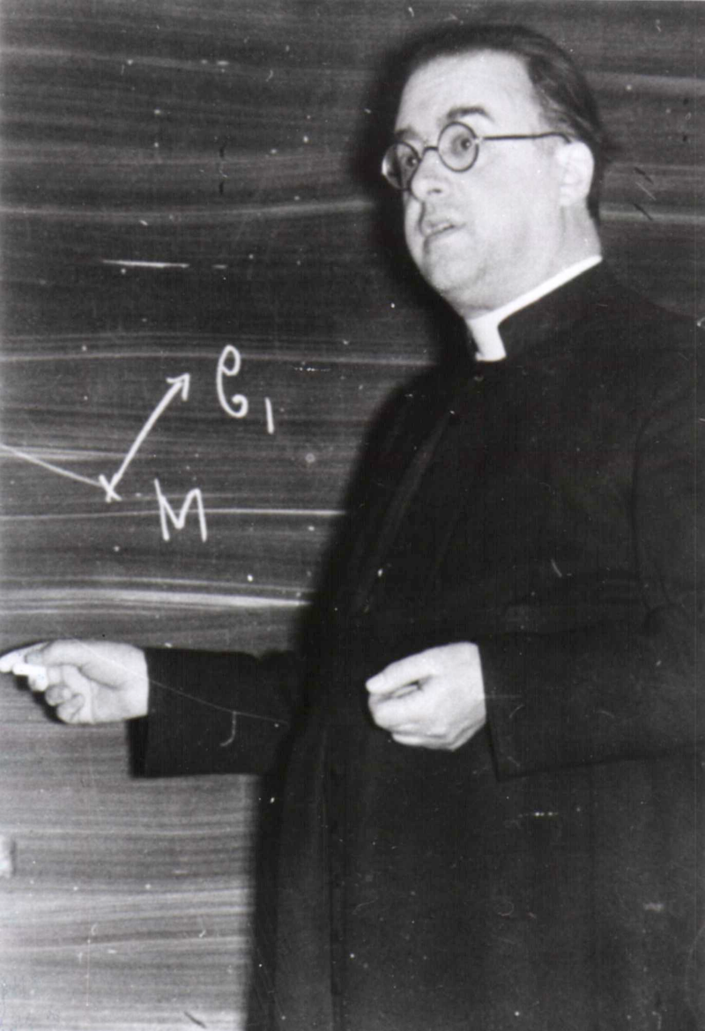
Abbé Georges Lamaître, Father of Big Bang Theory

Personal Notes:
“..He (the Christian researcher) knows that not one thing in all creation has been done without God, but he also knows that God nowhere takes the place of His creatures. Omnipresent divine activity is everywhere essentially hidden. It never had to be a question of reducing the Supreme Being to the rank of a scientific hypothesis..

